NAME:Santhosh M R S
REGISTRATION NUMBER:RA2611003020184
ROOM 1:

Task 1 – What is Networking?
1. I opened the “What is Networking?” room and started with the first task.
2. I read the explanation of a network and how devices can be connected together.
3. I reviewed the example showing Alice, Bob and Jim as devices/people connected in a network.
4. I answered the question asking for the key term used for devices that are connected together.
Question: What is the key term for devices that are connected together?
Answer: Network
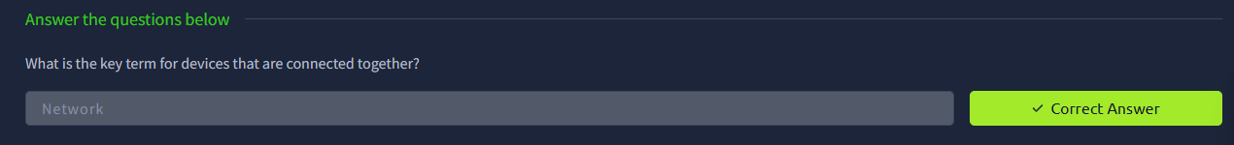

What I learned: A network is a group of connected devices that can communicate with each other. I also understood that networking is important in cybersecurity because computers and other devices depend on networks to exchange information.

Task 2 – What is the Internet?
1. I moved to the section explaining the Internet as a large network made from many smaller networks.
2 . I read the example using Alice, Zayn, Toby, Bob and Jim to understand how different networks can communicate.
I noted the distinction between private networks and public networks.
4. I answered the question about the person who invented the World Wide Web.
Question: Who invented the World Wide Web?
Answer: Tim Berners-Lee
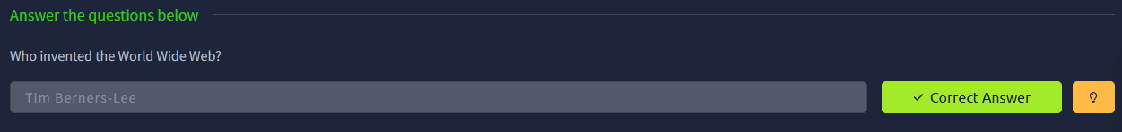
What I learned: The Internet is made up of many smaller networks connected together. I also learned that the World Wide Web was created by Tim Berners-Lee and that networks can be described as private or public.

Task 3 – Identifying Devices on a Network
1. I studied the two main ways used to identify a device on a network: an IP address and a MAC address.
2. I reviewed the explanation of IPv4 addresses and the four sections, called octets.
3. I compared public and private IP addresses using the examples given in the room.
4. I read about IPv6 and why it was introduced to provide a much larger address space.
5. I then studied MAC addresses and how a network interface can be identified by a MAC address.
6. I opened the interactive lab using the View Site option and followed the lab scenario involving Bob and Alice.
7. In the lab, I used the provided MAC-address spoofing exercise to make the device appear as the permitted device and checked the result.
Question: What does the term “IP” stand for?
Answer: Internet Protocol
Question: What is each section of an IP address called?
Answer: Octet
Question: How many sections does an IPv4 address have?
Answer: 4
Question: What does the term “MAC” stand for?
Answer: Media Access Control
Question: What flag is obtained after the MAC-address spoofing exercise?
Answer: THM{YOU_GOT_ON_TRYHACKME
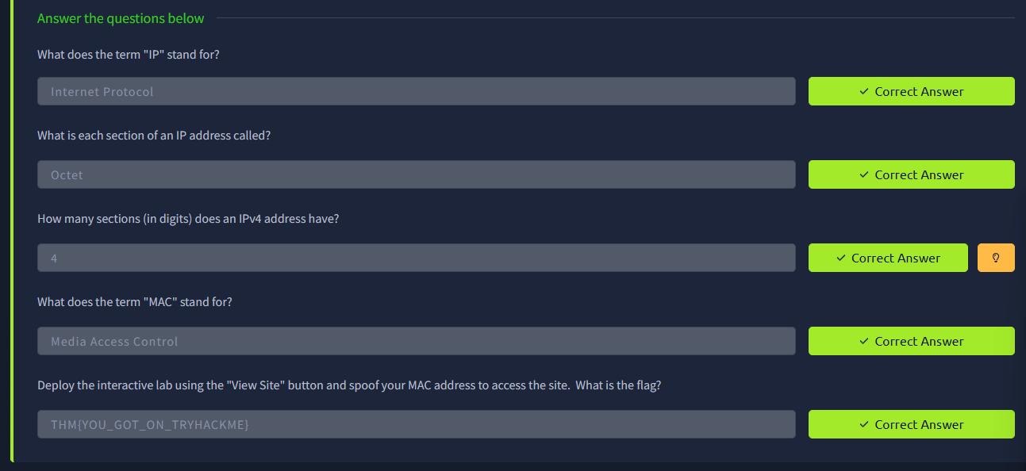

What I learned: I learned that an IP address is used for logical identification on a network, while a MAC address identifies a network interface. I also understood the difference between public and private IP addresses and the basic idea behind MAC-address spoofing.

Task 4 – Ping (ICMP)
1. I opened the Ping (ICMP) task and read how ping is used to check whether a network connection is available.
2. I noted that ping uses ICMP packets and measures the response time between the source and destination.
3. I reviewed the basic ping syntax.
4. I used the task's interactive environment to ping the required address and checked the returned result.
5. I recorded the flag shown by the exercise.
Question: What protocol does ping use?
Answer: ICMP
Question: What is the syntax to ping 10.10.10.10?
Answer: ping 10.10.10.10
Question: What flag is obtained when pinging 8.8.8.8?
Answer: THM{I_PINGED_THE_SERVER}
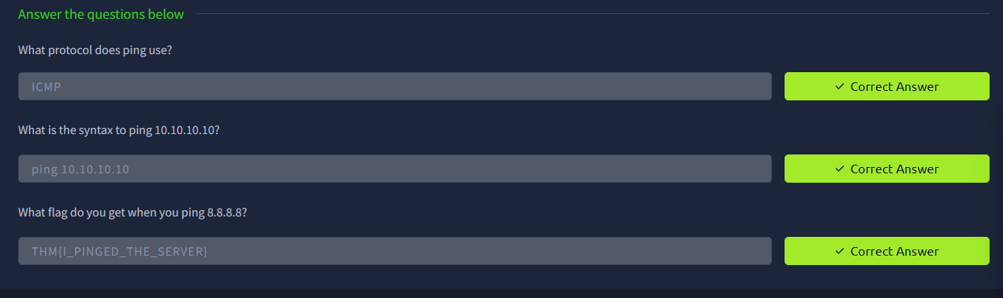
What I learned: Ping is a basic network troubleshooting tool. It uses ICMP to send requests and receive replies, which helps determine whether a destination can be reached and gives an idea of response time.

Task 5 – Continue Your Learning
1. I reached the final task of the room.
2. I opened the linked “Intro to LAN” learning room as instructed.
3. I marked the task as completed after opening the next room.
What I learned: This final task showed me how the networking fundamentals in this room connect to the next networking topic.
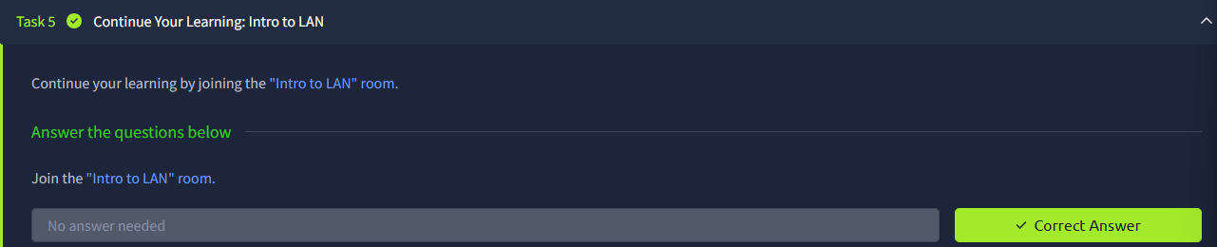

Name: Santhosh M R S
Registration Number: RA2611003020184

ROOM 2:

Task 1 – OSI Model

Steps Followed:
- I first opened the “Intro to Networking” room on TryHackMe.
- I read through the introduction to understand the purpose of the room.
- I started with the OSI model and went through its seven layers.
- I studied the role of the Application, Presentation and Session layers.
- Next, I learned about the Transport, Network, Data Link and Physical layers.
- I reviewed how these layers work together while information is transferred between devices.

Question:
How many layers are present in the OSI model?
Answer: 7

Question:
Name the seven layers of the OSI model.
Answer: Application, Presentation, Session, Transport, Network, Data Link and Physical.

What I learned:
I understood that the OSI model divides network communication into seven separate layers. Each layer performs a particular function, and together they help devices communicate with one another.
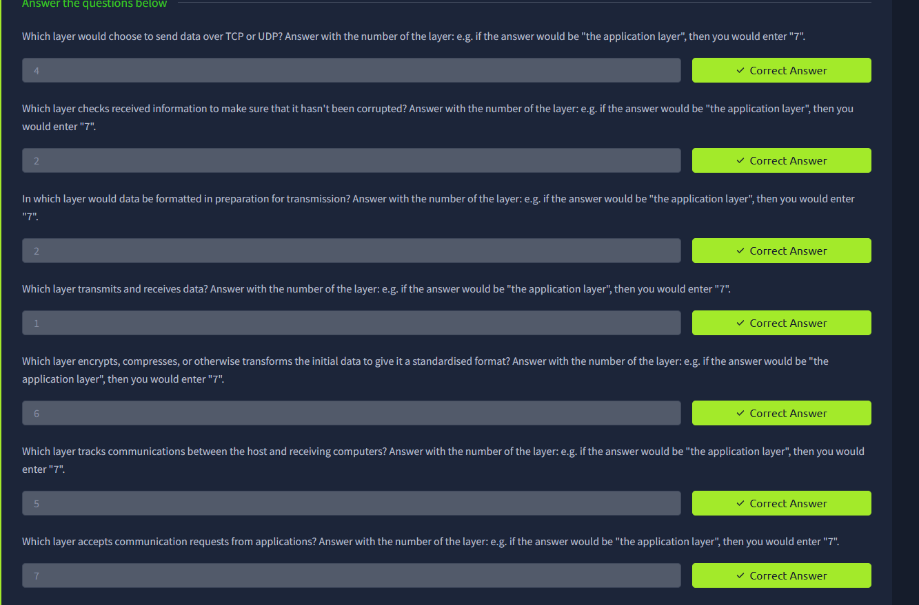
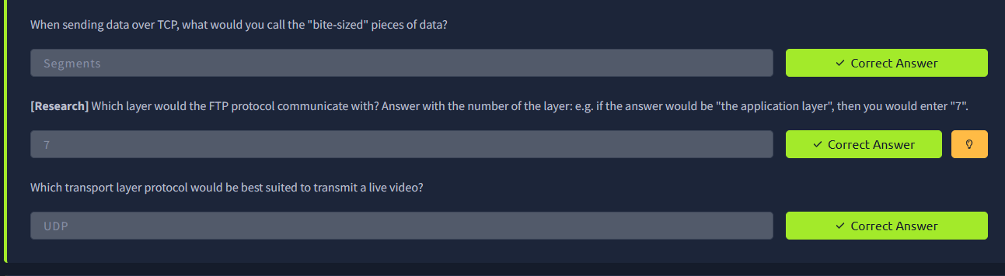

Task 2 – Encapsulation and De-encapsulation

Steps Followed:
- I continued to the section that explained how data is prepared before being transmitted.
- I studied how additional information is attached to the data at different networking layers.
- I learned how the data changes into a segment or datagram, packet and then frame.
- I then looked at what happens when the data reaches the destination device.
- I understood how the additional information is removed while moving back through the layers.

Question:
What is the process of adding information to data called?
Answer: Encapsulation

Question:
What is the process of removing that information called?
Answer: De-encapsulation

What I learned:
I understood how data is prepared for transmission by adding layer-specific information. I also learned that this information is removed when the data reaches the receiving device.
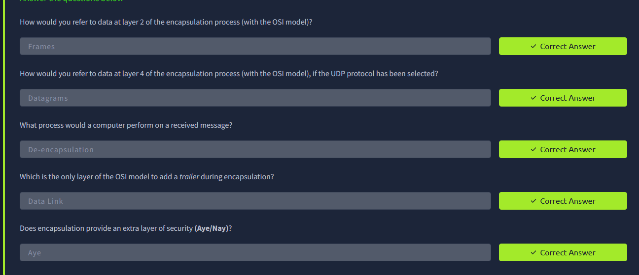

Task 3 – TCP/IP Model

Steps Followed:
- I proceeded to the section covering the TCP/IP model.
- I studied the different layers included in the model.
- I learned about the Application, Transport, Internet and Network Interface layers.
- I compared the TCP/IP model with the OSI model.
- I understood that some functions from the OSI model are combined in the TCP/IP model.

Question:
How many layers are included in the TCP/IP model?
Answer: 4

Question:
What are the four layers of the TCP/IP model?
Answer: Application, Transport, Internet and Network Interface.

What I learned:
I learned that the TCP/IP model is a practical model used to describe network communication. I also understood the relationship between the TCP/IP and OSI models.
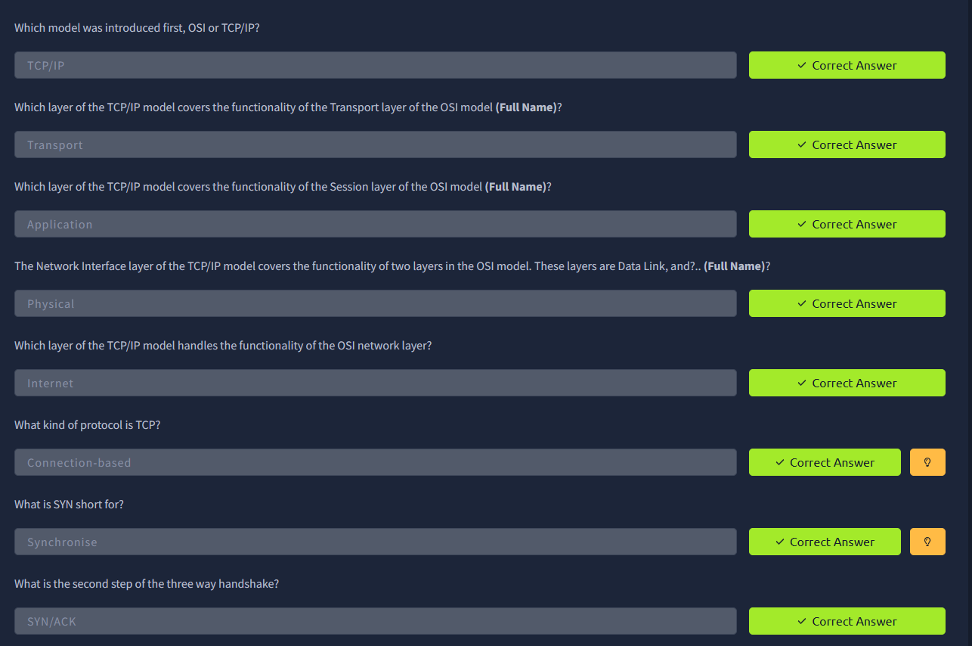

Task 4 – TCP Three-Way Handshake

Steps Followed:
- I moved to the section that explained TCP connections.
- I studied how TCP creates a connection between two devices.
- I went through the messages exchanged during the connection setup.
- I learned the sequence SYN, SYN-ACK and ACK.
- I understood that this process takes place before normal TCP communication begins.

Question:
What are the three messages used in the TCP handshake?
Answer: SYN, SYN-ACK and ACK.

What I learned:
I learned how TCP sets up a connection between devices. The three-way handshake helped me understand the initial communication required before data can be exchanged.

Task 5 – Ping (ICMP)

Steps Followed:
- I opened the Ping (ICMP) section.
- I read about the purpose of the ping command.
- I learned that ping can be used to determine whether a destination is reachable.
- I studied the role of the ICMP protocol in ping.
- I went through the basic command syntax.
- I used the provided environment and observed the response from the destination.

Question:
Which protocol is used by ping?
Answer: ICMP

Question:
What command is used to ping 10.10.10.10?
Answer: ping 10.10.10.10

What I learned:
I learned that ping is useful for checking basic network connectivity. I also understood that it uses ICMP and that the returned response can provide information about connectivity and response time.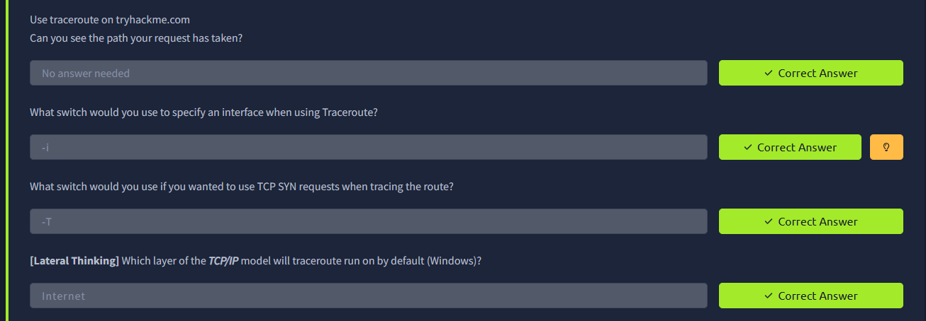

Task 6 – Traceroute

Steps Followed:
- I proceeded to the Traceroute section.
- I read about how traceroute works.
- I learned how it identifies the route towards a particular destination.
- I studied the intermediate hops through which the network traffic passes.
- I reviewed the example shown in the room to understand the output.

Question:
What is the purpose of traceroute?
Answer: It is used to find the path and intermediate hops taken to reach a destination.

What I learned:
I learned that traceroute helps identify the route followed by network traffic. It can also be useful for understanding where a connection may experience problems.
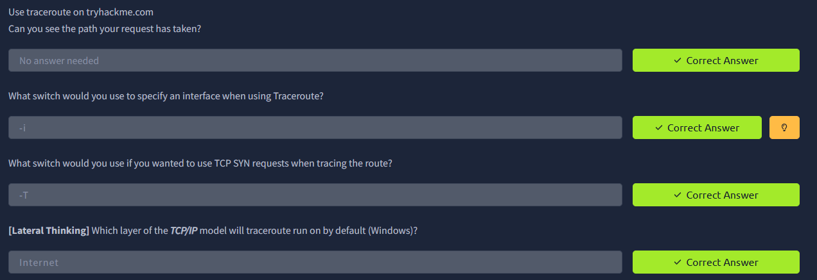

Task 7 – WHOIS

Steps Followed:
- I moved to the WHOIS section.
- I learned the purpose of the WHOIS lookup.
- I studied the example information returned for a domain.
- I looked at details such as registration information and name servers.
- I understood that the information available may vary depending on privacy settings.

Question:
What is WHOIS used for?
Answer: It is used to obtain information about a registered domain.

What I learned:
I learned how WHOIS can be used to gather information about domains. I also understood that the results may contain registration-related details and information about name servers.
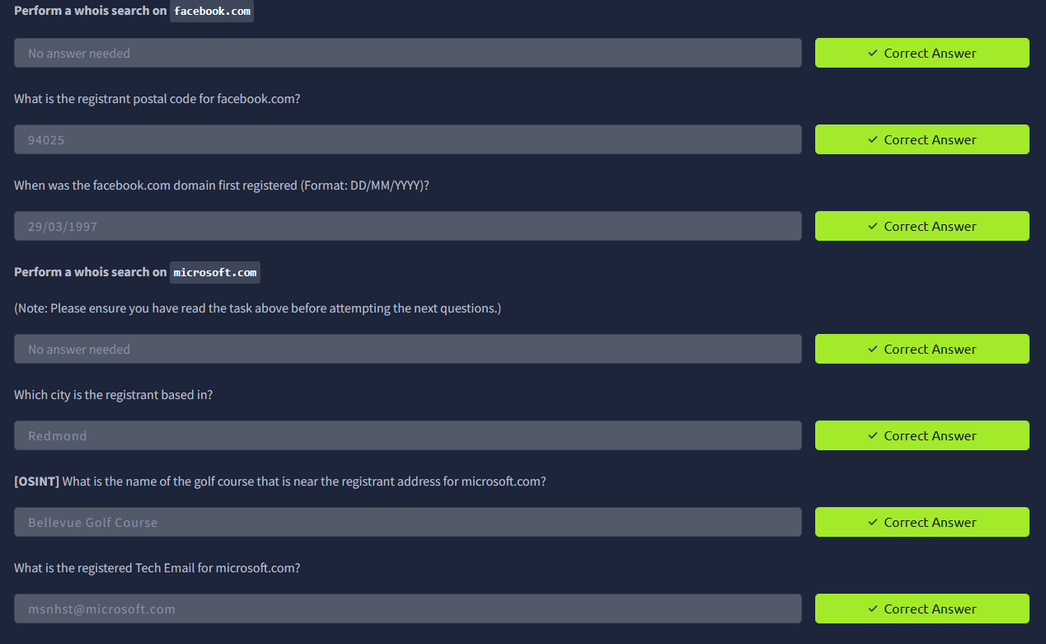

Task 8 – DNS

Steps Followed:
- I opened the DNS section of the room.
- I first learned why DNS is required when accessing websites using domain names.
- I studied how DNS converts a domain name into its corresponding IP address.
- I went through the different DNS servers involved in the lookup process.
- I studied the roles of recursive servers, root servers, TLD servers and authoritative name servers.
- I followed the overall process of a DNS request from beginning to end.

Question:
What is the full form of DNS?
Answer: Domain Name System

Question:
What is the main function of DNS?
Answer: To convert domain names into IP addresses.

What I learned:
I learned how DNS helps users access websites using easy-to-remember domain names instead of IP addresses. I also understood the basic process followed by DNS servers to find the required record.

Task 9 – dig and TTL

Steps Followed:
- I moved to the section explaining the dig command.
- I learned that dig can be used to obtain DNS information manually.
- I examined the ANSWER section of a DNS response.
- I studied the TTL value shown in the response.
- I learned how TTL controls the duration for which a DNS record can stay in the cache.

Question:
Which command can be used to query DNS information manually?
Answer: dig

Question:
What does TTL tell us?
Answer: It indicates how long a DNS record can remain cached.

What I learned:
I learned how the dig command can be used to examine DNS records. I also understood the purpose of TTL and how DNS caching allows information to be stored temporarily.
